UCS2601 – Internet Programming

Mini Project Report



Department of Computer Science and Engineering

Sri Sivasubramaniya Nadar College of Engineering, Kalavakkam

Done By
1.Thirumoorthy J- 3122235001148
2. Vigneshar K- 3122235001156
3. VishnuKumar S– 3122235001164

Project Report
LandSecureX — AI-Driven Land Encroachment Detection System

1. Problem Statement
Land encroachment on government-owned property is a significant and persistent issue, especially in rapidly urbanizing regions. Unauthorized constructions and illegal occupation of land lead to loss of public resources, legal disputes, and challenges in urban planning.
Traditional methods for detecting encroachment rely heavily on manual surveys and field inspections, which are:
- Time-consuming and expensive
- Prone to human error and inconsistency
- Inefficient for monitoring large geographic areas
- Reactive rather than proactive

Proposed Solution
LandSecureX automates detection using:
- Geospatial land registration
- AI-based satellite image comparison
- Multi-metric forensic scoring
- Real-time alert system with PDF reports
- Analytics dashboard

Objectives
- Develop AI-based structural change detection
- Implement geospatial polygon storage using PostGIS
- Build an intuitive web dashboard
- Enable automated alerting with reports
- Support both single and bulk scanning

2. Abstract
LandSecureX is a full-stack, AI-driven government land encroachment detection and monitoring system. It integrates computer vision-based change detection algorithms, a geospatial PostGIS database, a real-time interactive GIS dashboard, and an automated forensic alert pipeline.
The system enables government authorities to:
- Register land parcels on an interactive map
- Perform AI-based structural change detection using satellite imagery
- Detect unauthorized construction through a forensic scoring engine
- Generate official PDF reports
- Send automated email alerts to landowners
The system consists of three major components:
- ML Engine: Python (FastAPI, OpenCV)
- Backend API: Node.js (Express + PostgreSQL/PostGIS)
- Frontend: React with Leaflet.js

3. System Overview
Service | Technology | Port
Frontend | React | 3000
Backend | Node.js (Express) | 5001
ML Engine | FastAPI | 8000
Database | PostgreSQL (PostGIS) | 5432

4. Technology Stack
Frontend (GIS Dashboard)
- Framework: React.js
- Mapping Engine: Leaflet.js
- Map Providers: ESRI World Imagery (Current), ArcGIS Clarity (Archival), OpenStreetMap, National Geographic.
- Key Libraries: leaflet-draw (spatial editing), leaflet-image (snapshot capture), papaparse (CSV processing).
Backend (API & Logic)
- Runtime: Node.js (Express.js)
- Database: PostgreSQL with PostGIS extension (Spatial Database).
- Security: JWT (JSON Web Tokens) & Bcrypt password hashing.
- Reporting: PDFKit (Forensic report generation).
- Communication: Nodemailer (Automated Email Alerts).
Machine Learning Engine (Computer Vision)
- Framework: FastAPI (Python)
- Image Processing: OpenCV, NumPy.
- Forensics: Scikit-image (SSIM analysis).
- Communication: RESTful API for image processing requests.

5. System Architecture

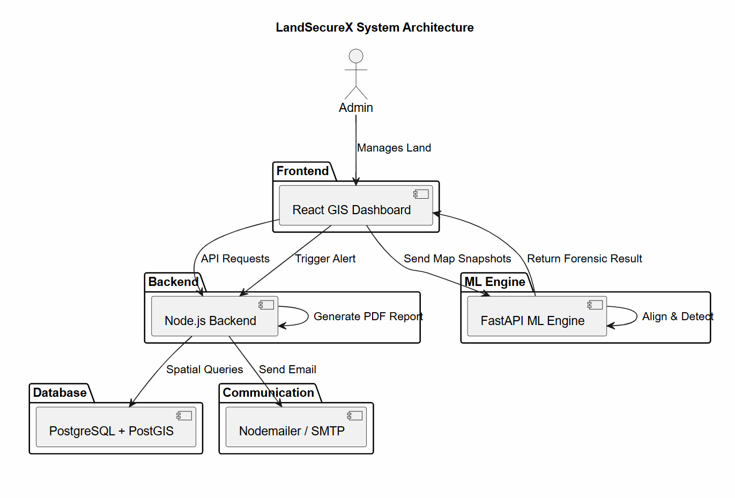

6. Sample Screenshots:

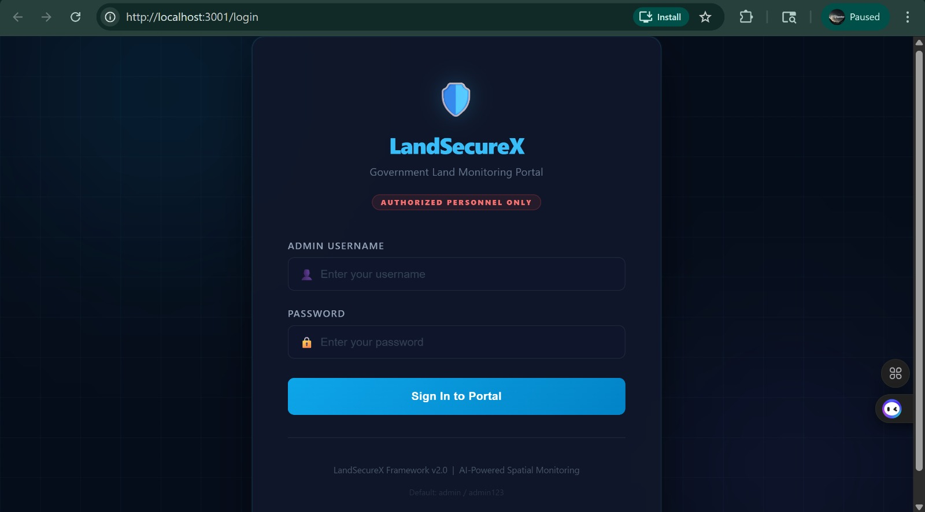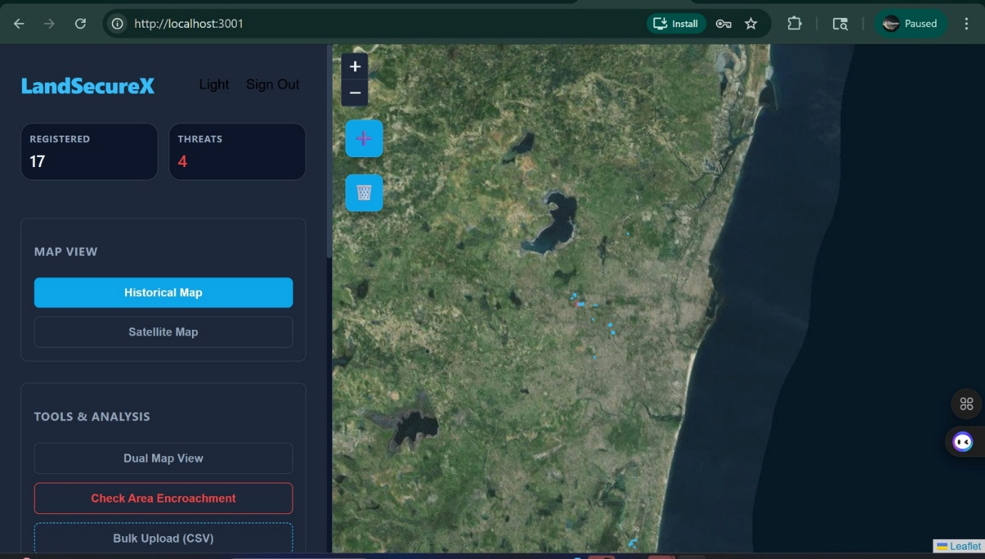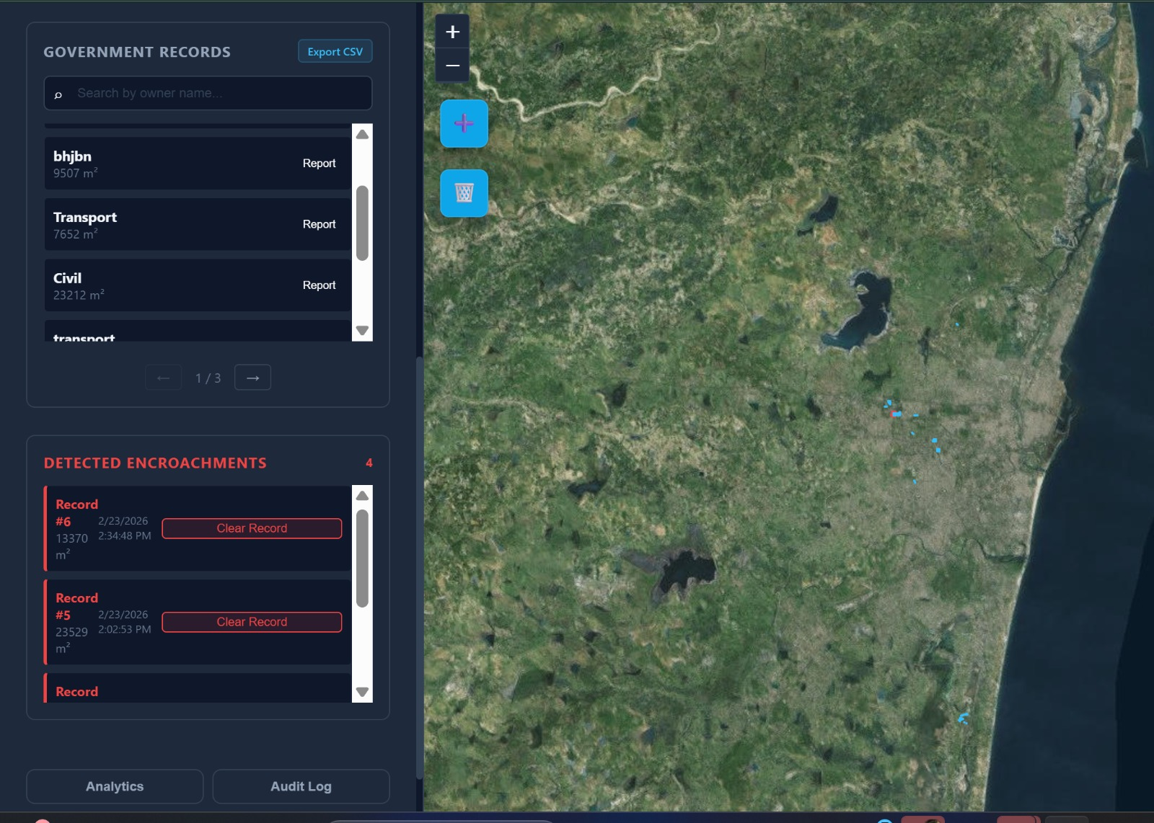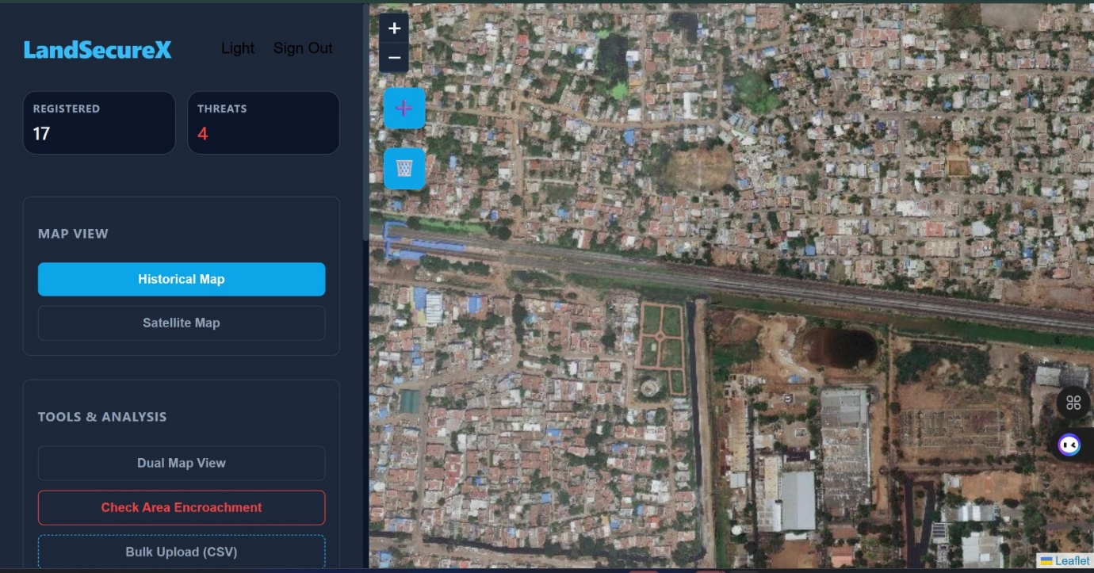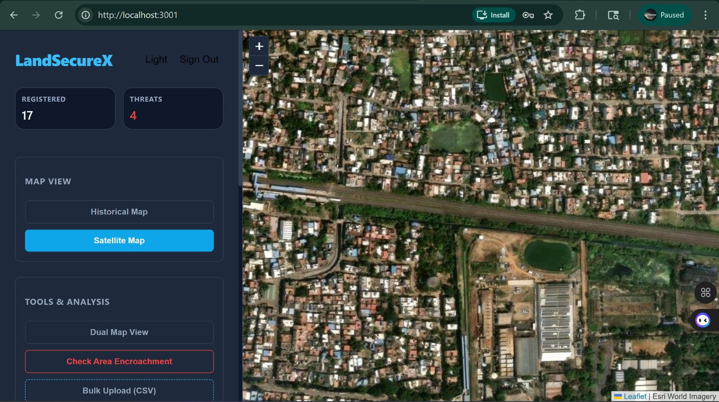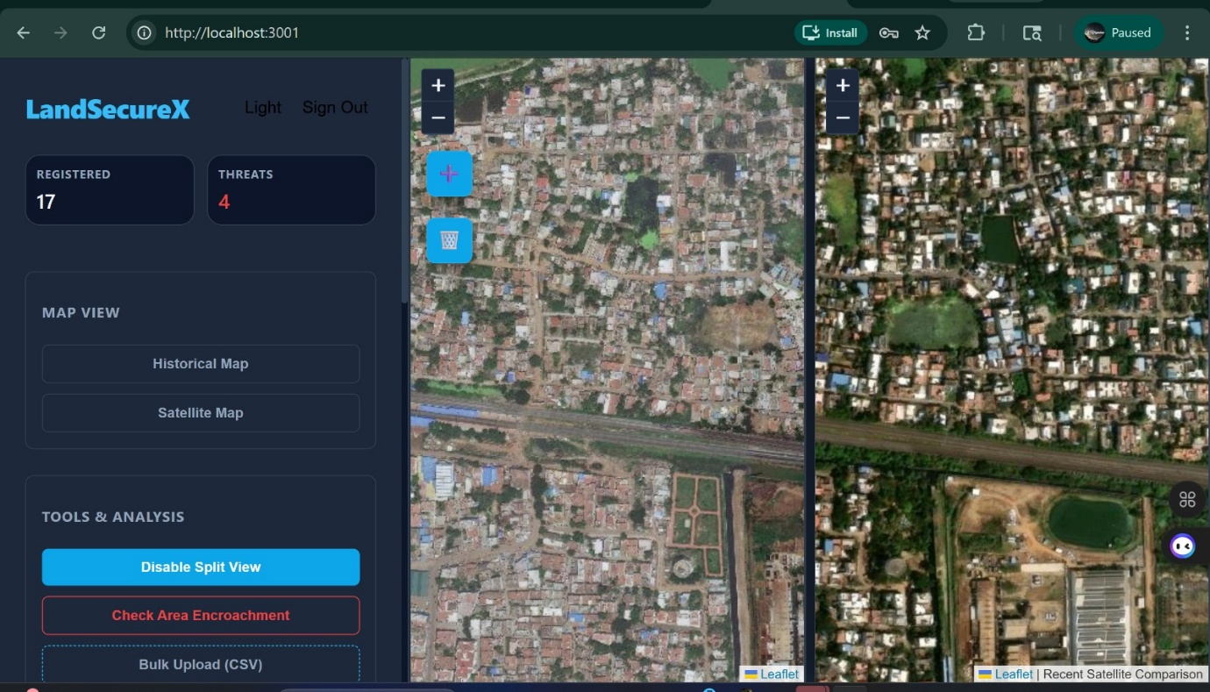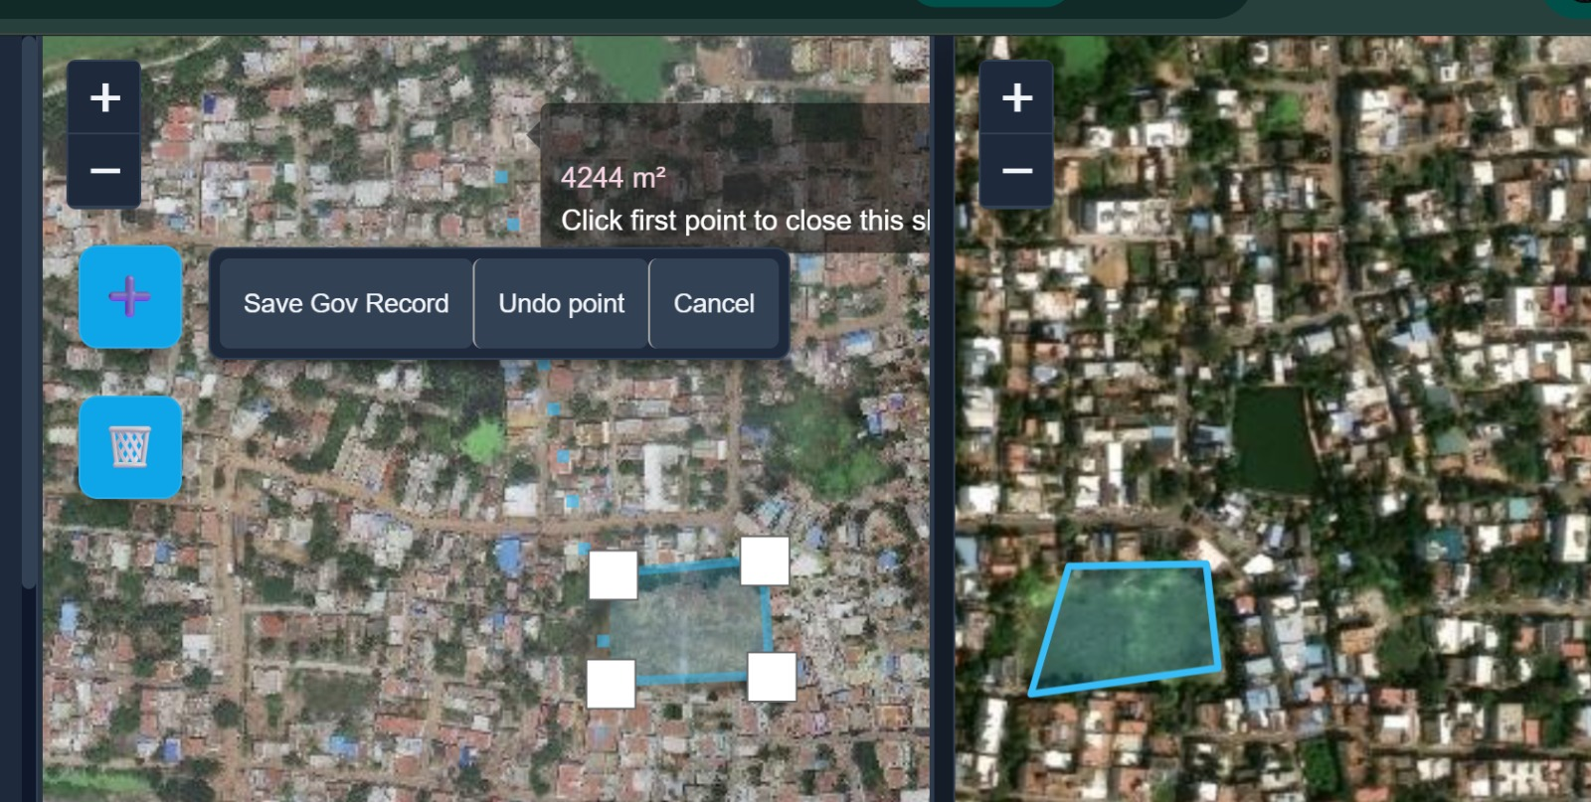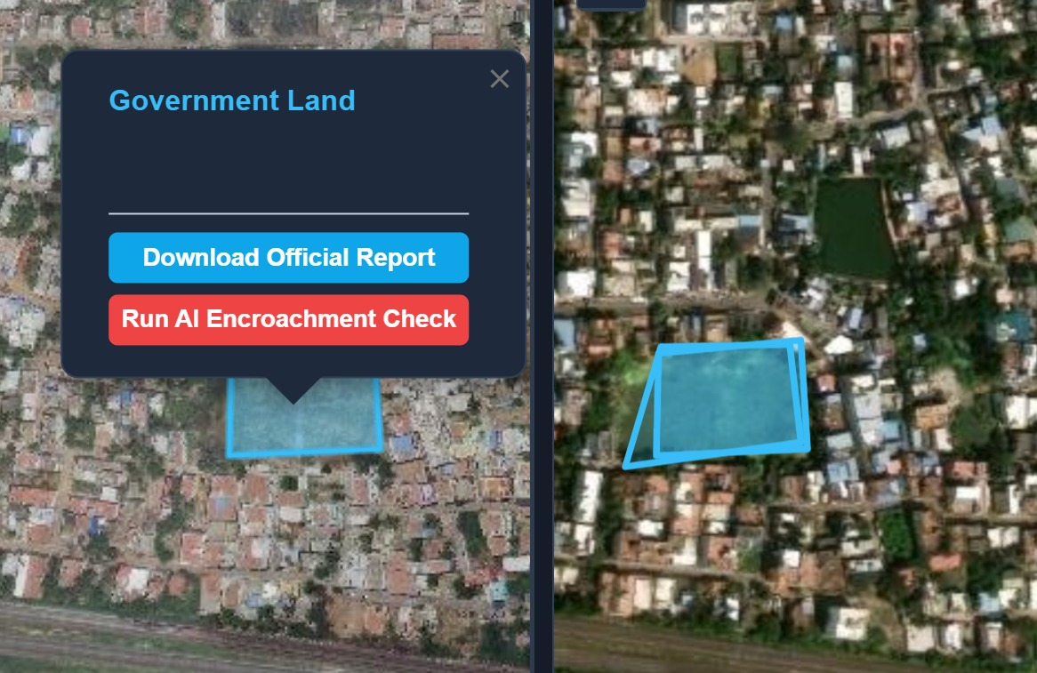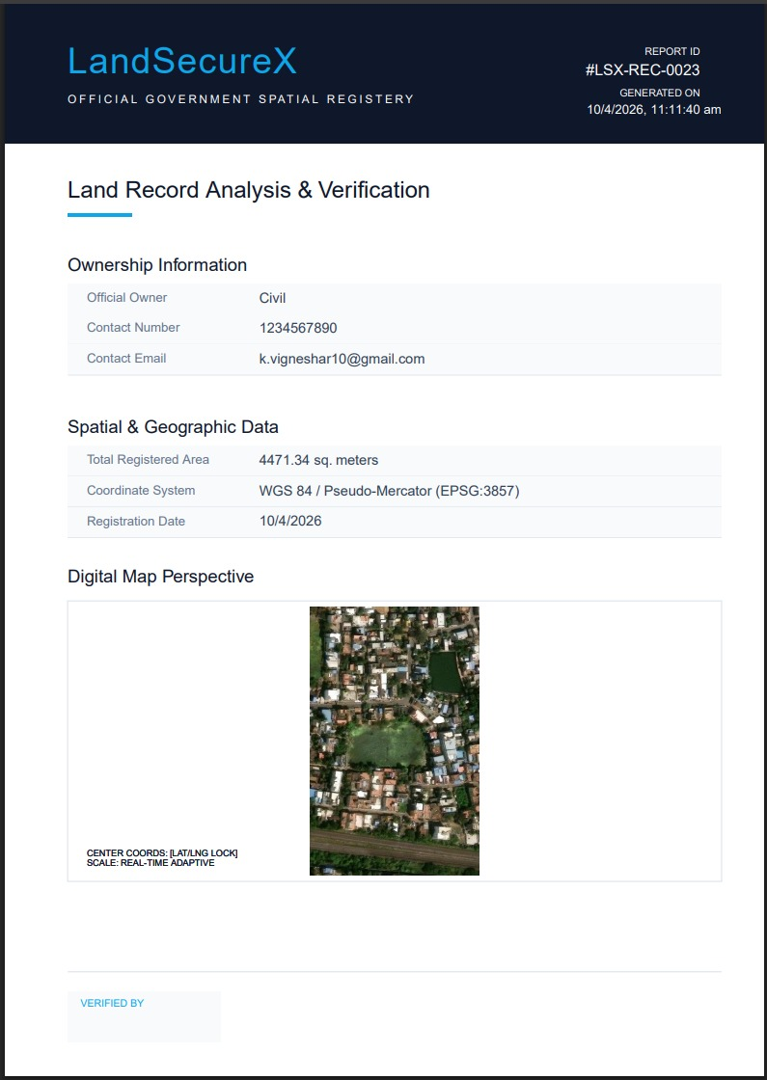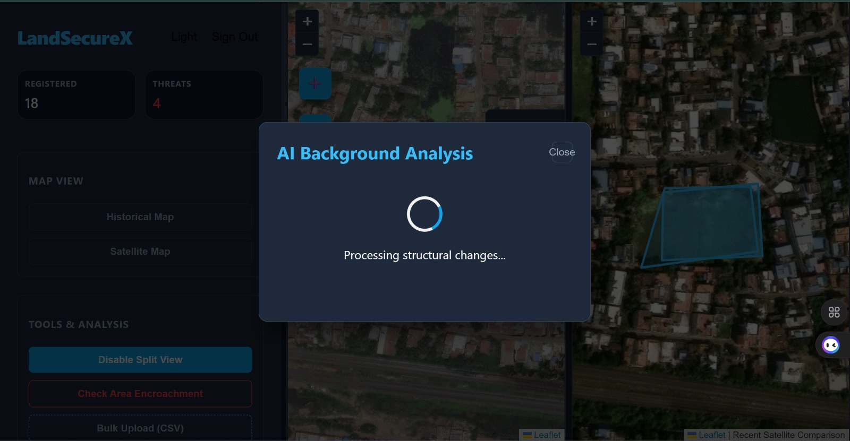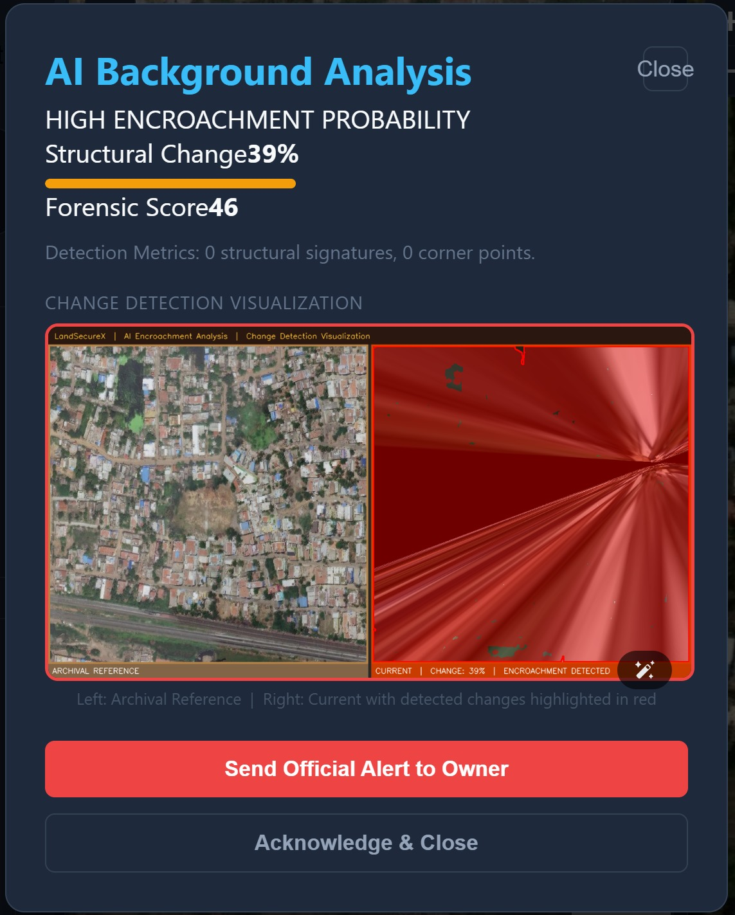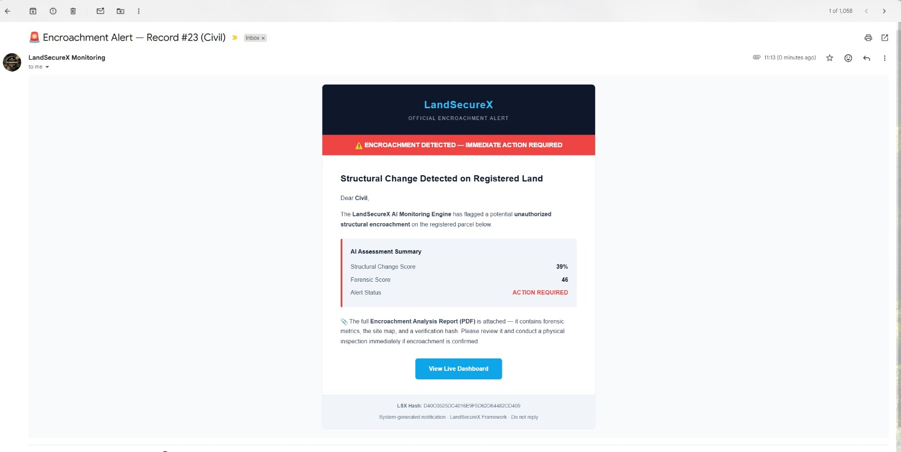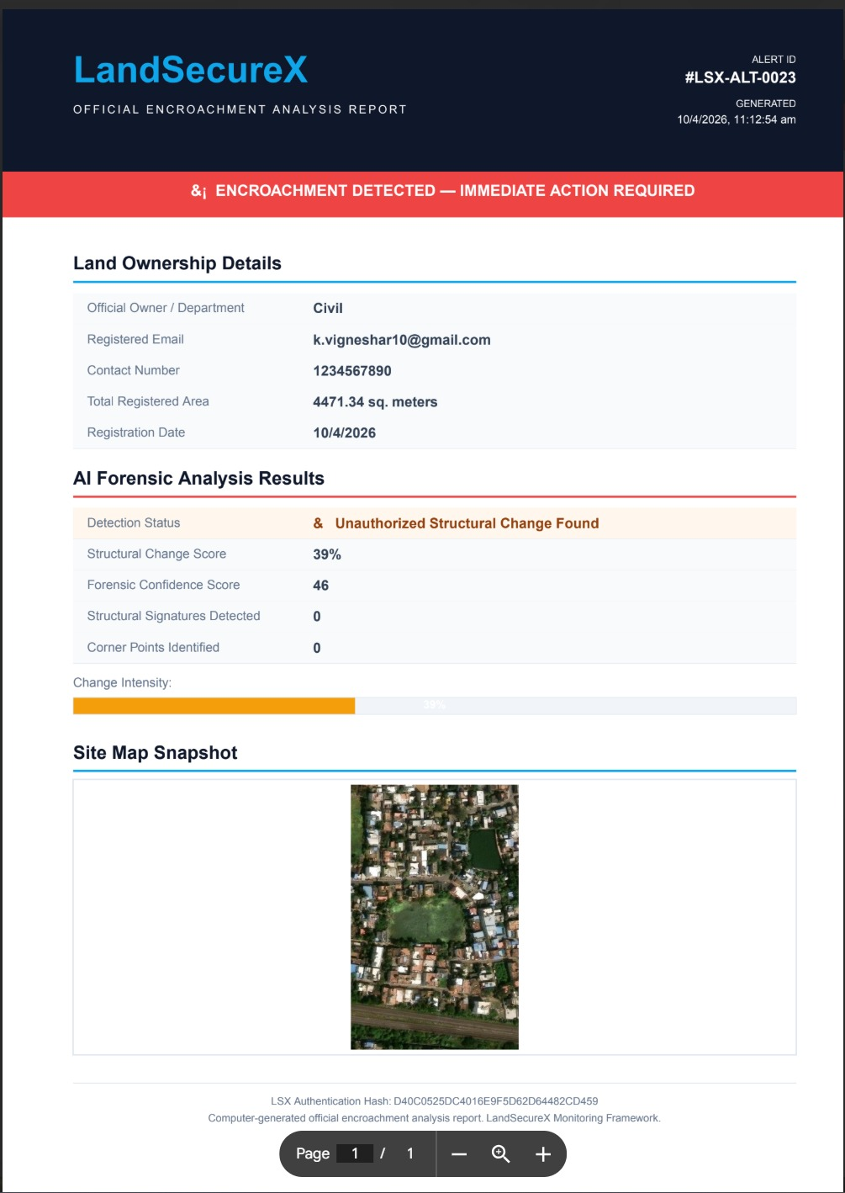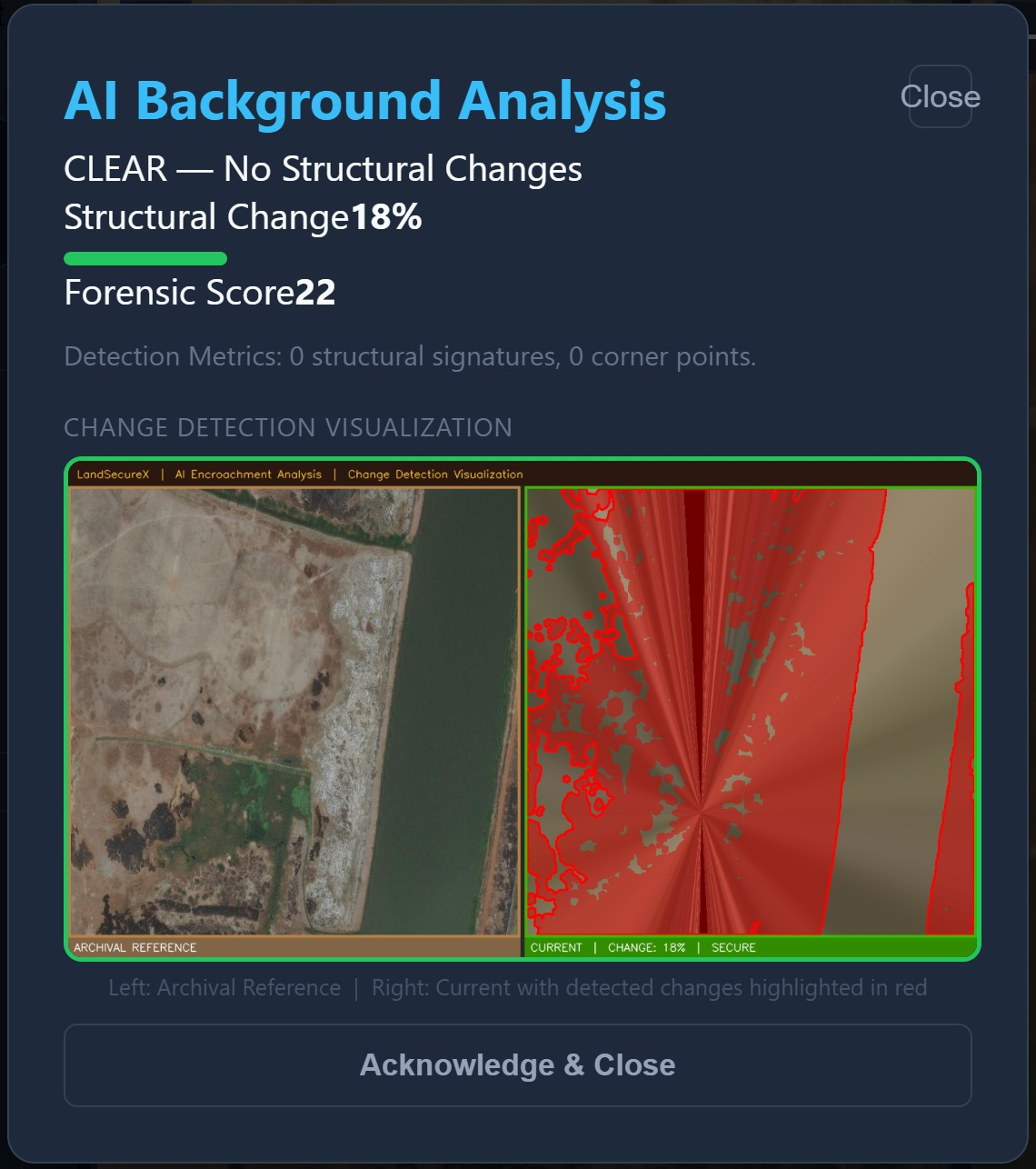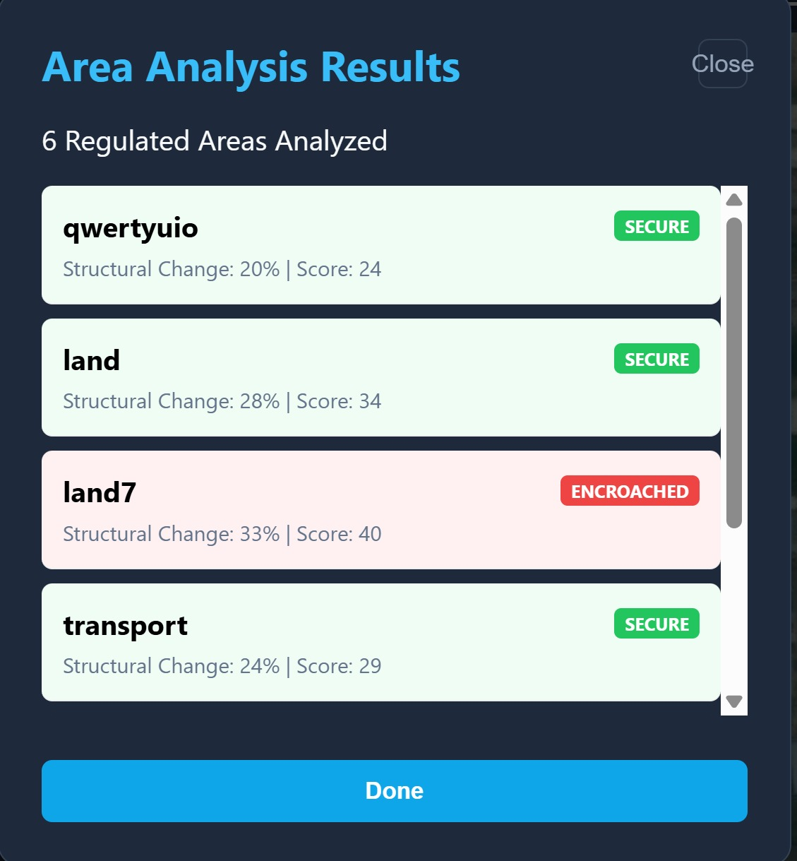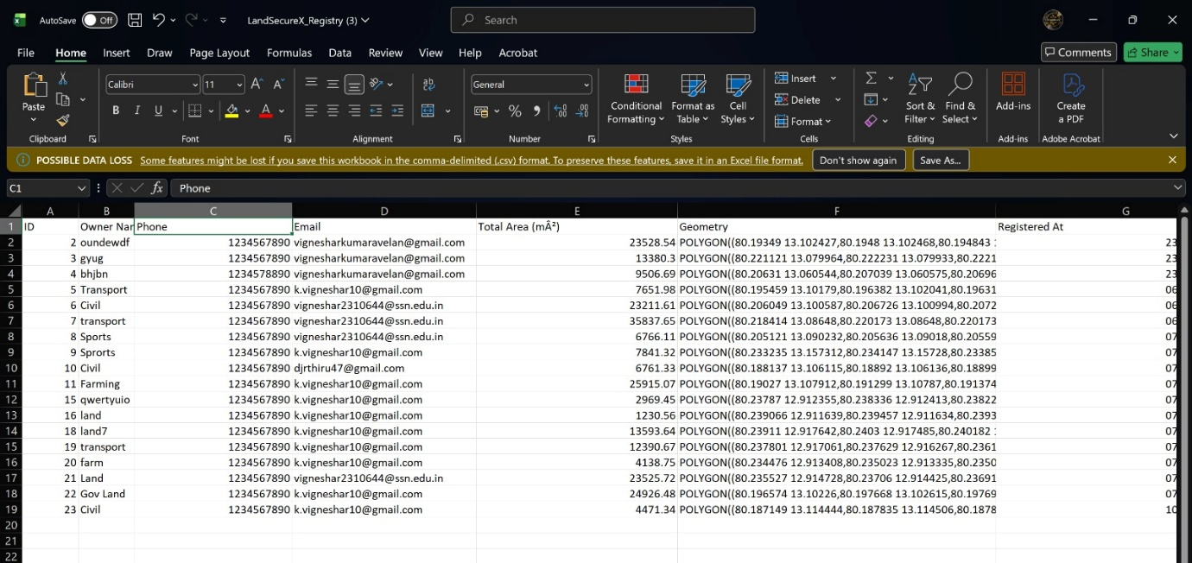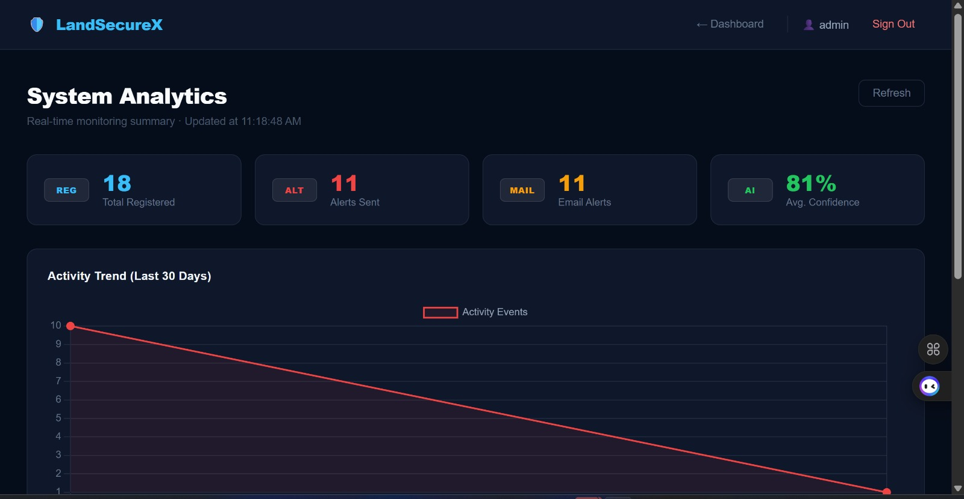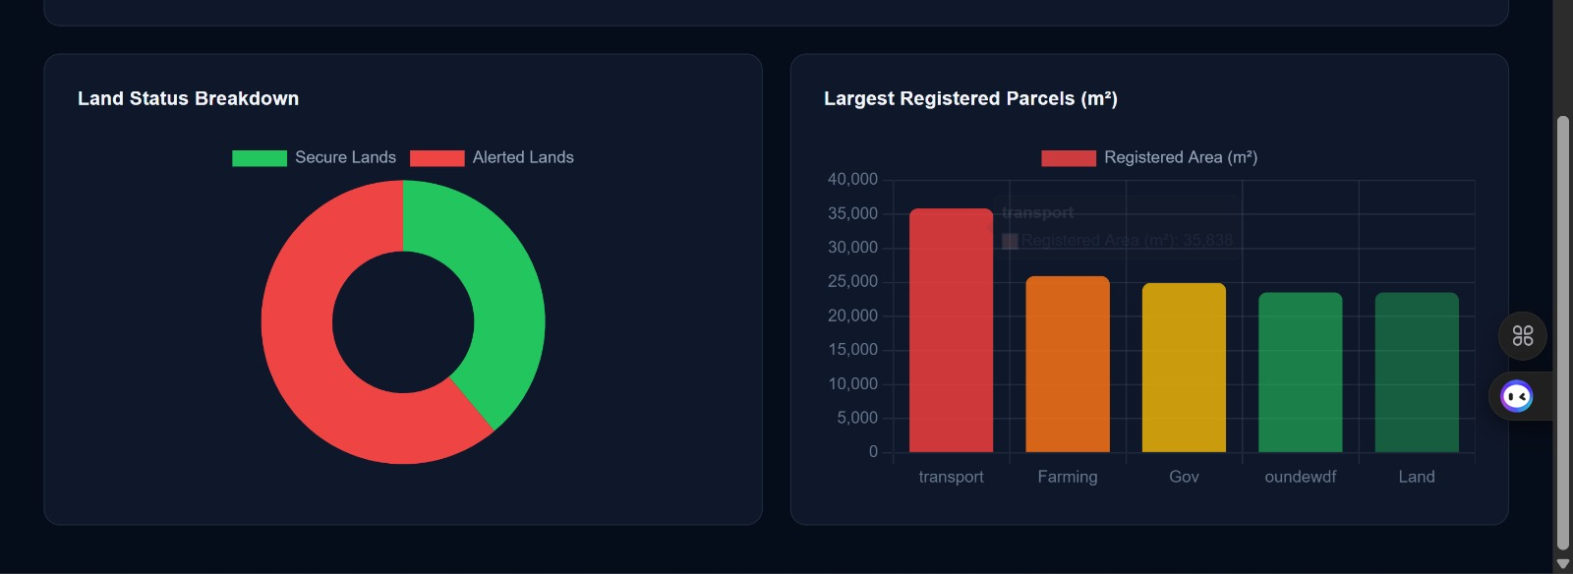

7. Core Features
7.1. Geospatial Land Registry
- Interactive map interface for visualizing government land.
- Drawing Tools: Draw, edit, and delete polygon boundaries directly on the map.
- Bulk Import: Upload land records from CSV files with coordinate data.
- Export: Download the entire registry as a CSV file.

7.2. AI Encroachment Detection
- Dual-Map Sync: Side-by-side comparison of historical reference data vs. real-time satellite imagery.
- Automated Alignment: Uses ORB feature matching and homography to align images, correcting for satellite sensor offsets.
- Structural Analysis: Extracts man-made signatures (lines, corners, rigid footprints) while filtering out organic changes (vegetation, shadows).
- Forensic Scoring: A weighted multi-metric score (SSIM + Structural Gain) determines if a change is a genuine encroachment.

7.3. Forensic Reporting & Alerts
- Live PDF Generation: Creates official government reports featuring owner details, spatial metrics, and live map snapshots.
- Automated Alerts: One-click email alerts sent to land owners/departments with an attached forensic analysis PDF.
- Digital Signatures: Each report includes a secure verification hash for authenticity.

7.4. Analytics Dashboard
- Real-time tracking of active threats and alerts sent.
- Weekly detection trends and high-risk land monitoring.
- Activity logging for administrative transparency.

8. Machine Learning Algorithm

The ML engine uses a "Morphological-Rigid-Body" detection approach:
- Image Alignment: Digital Image Registration (DIR) using ORB and RANSAC to ensure pixel-perfect comparison.
- Denoising: Bilateral filtering to remove "soft" environmental noise while preserving "hard" architectural edges.
- Feature Extraction:
  - Hough Lines: Detects man-made linear structures (walls, fences).
  - Harris corners: Detects architectural vertexes.
  - Contours: Identifies rigid building footprints (rectangles, L-shapes).
- SSIM Analysis: Measures pixel-level structural similarity to detect general changes.
- Weighted Scoring: Combines all gains into a final index. (e.g., Building Gain * 50 + Line Gain * 4).

9. Database Schema
gov_land (Government Records)
- id: Unique Identifier
- owner_name: Registered Owner/Department
- geom: PostGIS Geometry (Polygon, WGS84)
- total_area: Calculated land area in square meters
- email/phone: Contact information for alerts

new_land (Detected Encroachments)
- id: Unique Identifier
- geom: Geometry of the detected unauthorized structure
- encroached_area: Severity of the encroachment
- detected_at: Timestamp of detection

10. API Summary
Backend APIs
- Authentication
- Land management
- Analytics
- Report generation
- Alert sending
ML API
- /detect → Image analysis

11. Data Flow
Land Registration
User → Map → Backend → Database
AI Detection
User → Image Capture → ML Engine → Results
Alert System
User → Backend → PDF → Email

13. Prototype
Initial OpenCV model used:
- Pixel difference
- Thresholding
- Contour detection
Later replaced by advanced ML pipeline.

14. Security
- JWT authentication
- bcrypt password hashing
- Input validation
- Parameterized queries
- Environment-based credentials

15. Limitations & Future Scope
Limitations
- No deep learning model
- Manual alert triggering
- Single-user system
- Open CORS policy

Future Enhancements
- CNN-based detection
- Automated scanning
- Multi-user roles
- Mobile application
- Drone integration

9. Conclusion
LandSecureX modernizes land surveillance by replacing manual physical inspections with AI-driven satellite monitoring. Its modular architecture and robust forensic capabilities provide a scalable solution for government departments to maintain the integrity of public land.
It is a complete AI-powered system combining:
- Computer Vision
- Geospatial Analysis
- Web GIS
- Backend Engineering
- Automated Communication
It provides an end-to-end solution for detecting and monitoring land encroachment efficiently and accurately.

